**BackEnd SetUp**

1. Clone <https://github.com/robertbutacu/medi-test/> locally
2. Open Intellij IDEA
3. Choose Import Project option

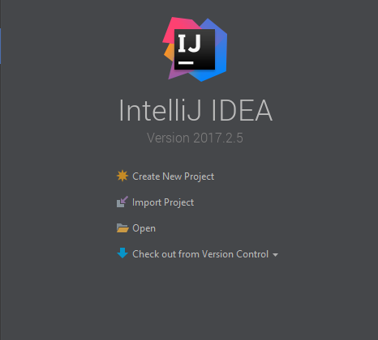

1. Choose meditest project

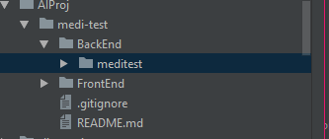

1. Press OK
2. Will appear a new window:

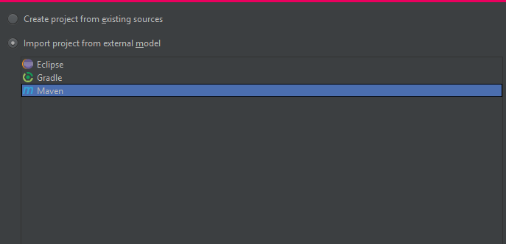

1. Choose “Import project from external model” and Maven option and press Next until the project is opened (I think there is a Finish button too)
2. In the bottom-right you will have a mini window and press auto import for external module

(and that will import the maven external libraries)

1. Press Run

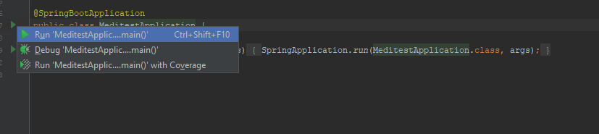

1. The project should run